$200 REWARD
DO YOU KNOW WHO THESE THIEVES ARE?
IF YOU DO, YOU CAN MAKE SOME MONEY AND DO A GOOD DEED AT THE SAME TIME
YOU COULD BE NEXT!
(818) 339-5817
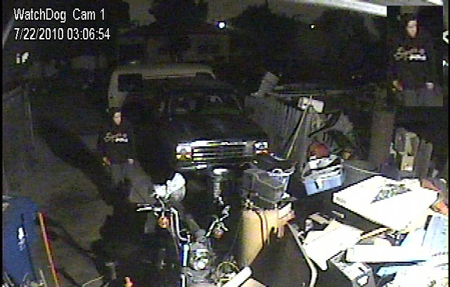
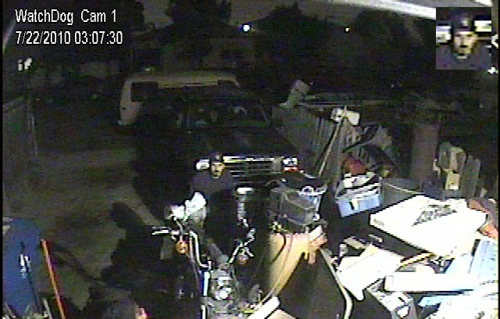
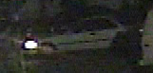
They stole a battery charger on 7/22/2010 at 3:06am
You can watch the video & get more details on the internet at the following URL: www.windowsconsulting.net/batt_charger

